Joshua Haupt, Charles Stewart Helf

jhaupt@siue.edu, malkav.amonra@gmail.com

LA CRIMES 2012 - 2015

CS 434 Project 1

The application being developed is a tool to analyze Los Angeles-area crime reports over time, beginning with the years 2012 through 2015. The intention is -- in addition to filing and storing these records for future recollection -- to understand trends and patterns in crime reporting and police activity. What proportion of certain crimes result in apprehension of the perpetrator(s)? Which crimes see the greatest difference between time of report and time of crime occurrence? When and where are most crimes likely to occur throughout the day, month, or year? Which crimes tend to always, often, rarely, or never trend together? These are but a few of the many fascinating questions that law enforcement and civilians alike might want answers to. It's in this spirit that the database in question is to be designed such that any possible questions of frequency, comparison, and probability with regard to the data collected can be accurately answered.

With regard to the data collected, this database will store several important types of information: crimes committed, relevant statutes violated, reports and statuses filed on occurrences of crimes, and officers who responded to reported crimes along with their departments. It should then go without saying that vital details relevant to those types of information will also be contained (for instance, reference numbers, officers have names and badge numbers; crime reports have dates filed and addresses of crime commission). As much relevant data as possible will be compiled to ensure that as many reasonable and interesting queries regarding crime reporting trends can be posed and answered effectively.

For this particular project, we have run into a couple of small issues. First, the data set we retrieved did not come with the names of the arresting officers so we will have to generate this data arbitrarily. We similarly do not have data sets for Los Angeles police departments and criminal statutes. If separate data for these cannot be located or effectively incorporated into this project, it will also have to be generated. Fortunately, the database maintainer has been helpful in regards to clarifying the meaning of the data in the database.

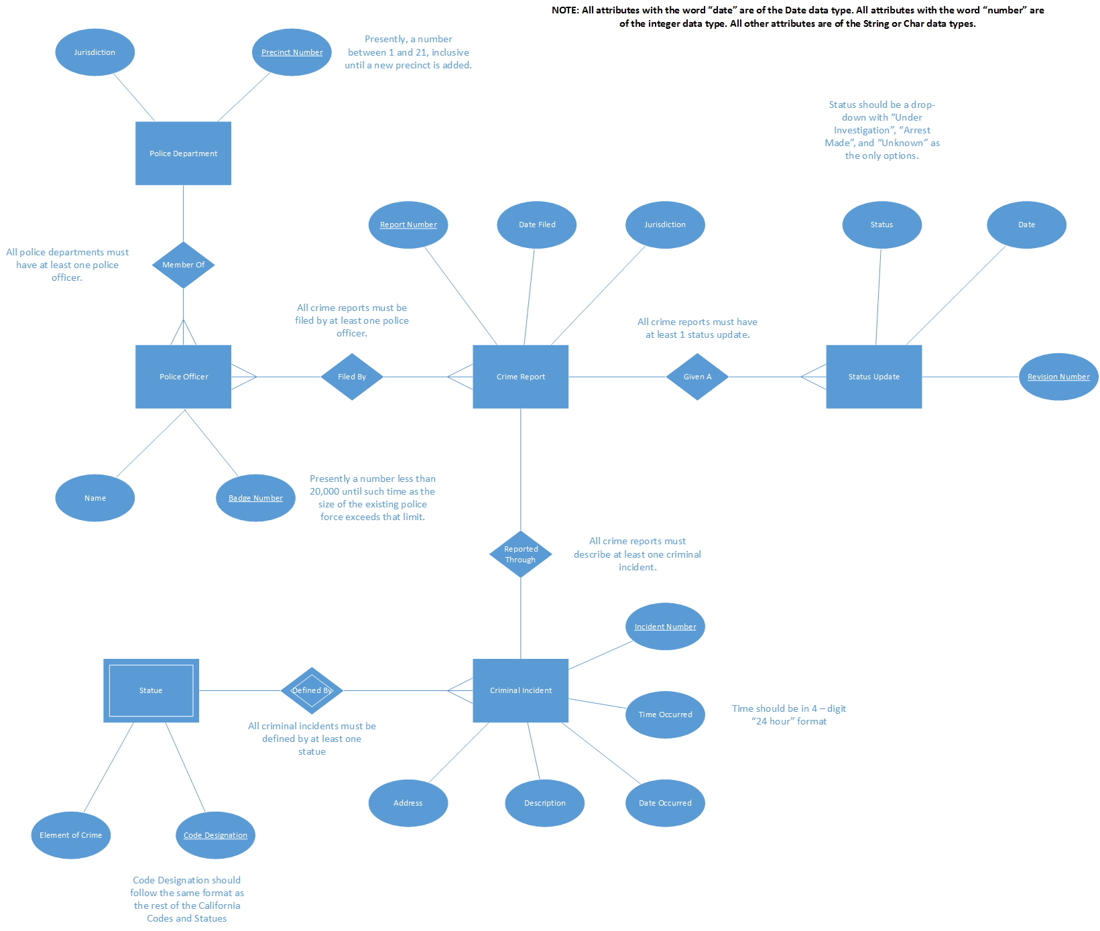

The team for this project consists of:

Charles Stewart Helf (malkav.amonra@gmail.com)

Josh Haupt (jhaupt@siue.edu)